

Employment Dynamics in Yorkshire and the Humber: Trends, COVID-19 Impacts and Future Projections

Registration Number: 250124837
Module: Introduction to Data Science (IJC437)
Word Count:

Introduction and Aims

Context and Motivation
Employment patterns are key indicators of regional economic health, reflecting structural changes, labour market resilience and responses to external shocks such as economic crises or global pandemics (Harari & Ward, 2022). In the United Kingdom, sectoral employment has shifted significantly over the past decade due to technological advancements, globalisation, demographic changes and evolving policy priorities (ONS, 2023). Analysing these patterns at a regional level is critical for informing local policy, investment decisions and workforce development strategies.
Yorkshire and the Humber represents one of the UK’s most diverse regional economies, combining traditional sectors such as Manufacturing and Construction with expanding service-oriented and digital industries. Recent years have seen significant economic transitions, including the decline of heavy industry, growth in healthcare and education, and disruption caused by the COVID-19 pandemic (Kaye, 2020). Examining employment trends across industries offers insights into the region’s adaptability, resilience and capacity to capitalise on emerging economic opportunities (Barzotto et al., 2025).
This study uses the Business Register and Employment Survey (BRES), which provides annual employment estimates across UK industries. Focusing on Yorkshire and the Humber between 2015 and 2024, the analysis identifies long-term employment trends, evaluates the impact of COVID-19 and projects potential changes through to 2030. The approach supports evidence-based decision-making for policymakers, businesses and workforce planners by highlighting region-specific employment dynamics.

Literature Review
Previous research on UK regional labour markets highlights persistent disparities in industrial structure and employment growth. Studies by the Office for National Statistics (ONS, 2023) and regional economic observatories show that northern regions, including Yorkshire and the Humber, continue to rely heavily on manufacturing and public services, while London and the South East lead in knowledge-intensive and digital industries.

Analyses of regional resilience (Martin & Sunley, 2015) suggest that economic adaptability depends on the diversity and flexibility of local industry bases. Regions with a mix of traditional and emerging sectors tend to recover more effectively from economic downturns. Within Yorkshire, the expansion of health and education sectors has been linked to demographic change and policy investment (Beatty & Fothergill, 2021), while growth in digital and professional services reflects the gradual shift towards a knowledge-based economy (Aparicio et al., 2021).
The COVID-19 pandemic further accentuated regional differences in employment. Research by the ONS (2020) reported uneven employment impacts across sectors, with hospitality, retail and construction experiencing steep short-term losses, while healthcare, information technology and logistics expanded to meet new demands. Forecasting studies such as PwC (2023) emphasise the need for data-driven regional analyses to understand post-pandemic recovery trajectories and future employment dynamics.
Despite this body of work, there is still a notable gap in fine-grained, region-specific analyses that combine recent longitudinal employment data with predictive modelling to assess Yorkshire’s evolving industrial composition. Much of the existing research focuses on national trends or short-term pandemic impacts, providing limited insight into how sectors are likely to evolve and what future employment patterns may look like at the regional level. There is also a lack of studies that integrate both traditional and emerging sectors to evaluate regional economic resilience comprehensively. Furthermore, not many analyses provide multi-year perspectives that capture ongoing trends and allow for reliable forecasting beyond immediate or short-term effects.
This study addresses these gaps by applying statistical analysis and forecasting to the BRES data for Yorkshire and the Humber. It provides an updated, data-driven evaluation of industry performance from 2015 to 2024 and produces projections to 2030, offering insights into both historical patterns and potential future developments in the region’s employment landscape

Aims and Research Questions
The primary aim of this research is to analyse employment trends across Yorkshire and the Humber between 2015 and 2024, assess the impact of the COVID-19 pandemic and forecast sectoral employment changes up to 2030 using regression-based projections. The research questions are:
- RQ1: Which industries have shown the most consistent employment growth between 2015 and 2024?
- RQ2: How did the COVID-19 pandemic (2019–2021) affect employment levels across different industries in Yorkshire?
- RQ3: Based on historical trends, which industries are projected to grow or decline by 2030?
These questions provide a structured framework for assessing historical trends, pandemic impacts and future workforce dynamics.

Methodology

Data Source and Collection
The dataset for this study was obtained from the UK Office for National Statistics Business Register and Employment Survey, which provides detailed annual employment data across UK industries. The subset used focuses on Yorkshire and the Humber between 2015 and 2024. The dataset included a column for Industry and separate columns for each year from 2015 to 2024. Each year column contained two sub-columns: one recording the number of employees to the nearest 1,000 and another containing flags, which provide metadata or quality indicators about the employment figures. This source was selected because it provides a reliable, longitudinal record of employment at the regional level, allowing for analysis of long-term trends, the effects of major events such as COVID-19, and projections for future employment.

Data Pre-processing and Cleaning
The raw dataset required cleaning and restructuring before analysis. Columns containing flags were removed as they did not contain relevant information. Industry names were standardised by removing numeric prefixes and trailing brackets using regular expressions to ensure consistent and readable labels. To facilitate analysis, the data was reshaped from its wide format, in which each year had a separate column, to a long format with three columns: Industry, Year, and Employees. The Year variable was converted to numeric, and employee counts were checked for missing or non-numeric values. The resulting tidy dataset was suitable for both descriptive and predictive analyses. All data processing was conducted in R using the readxl, tidyverse, stringr, ggplot2, ggrepel, and scales packages.

Data Analysis Techniques
The analysis was structured around the three research questions. Descriptive analysis summarised overall and industry-specific employment trends from 2015 to 2024 using line plots and grouped summaries. Comparative analysis calculated the percentage change in employment between 2019 and 2021 to quantify the impact of COVID-19 across industries. For predictive analysis, linear regression models were fitted to each industry with Year as the predictor and Employees as the response variable. These models provided estimates of employment in 2030 and allowed projected growth rates to be calculated. Visualisations were produced using ggplot2 to clearly communicate trends, changes, and projections.

Data Quality Considerations
The BRES dataset is survey-based and considered reliable for regional analysis, though sampling variation may affect smaller industries. No significant missing data was observed in the selected columns, and employment counts were consistently reported across the 2015–2024 period. The linear regression models assume that historical trends continue unchanged, which may not fully account for future economic shocks, policy interventions, or structural shifts (Casson & Farmer, 2014). These limitations were explicitly considered when interpreting results and generating forecasts.

Visualisation
Visualisation was central to communicating insights. Line plots were used to show employment trends over time for all industries and for the top five by total employment. Bar charts displayed percentage growth over the full period, COVID-19-related changes, and projected employment growth to 2030. Colours, labels, and consistent formatting were applied to improve clarity and readability. All figures were saved in high-resolution formats suitable for inclusion in the report.

Results

Overview of Employment Trends
Employment across Yorkshire and the Humber between 2015 and 2024 displayed both stability in traditional sectors and growth in emerging industries. The Health and Manufacturing sectors consistently employed the largest portions of the workforce. Health employment increased steadily from approximately 325,000 in 2015 to 367,000 in 2022, while Manufacturing fluctuated moderately between 240,000 and 286,000 employees. Other large sectors, including Education and Retail, showed comparatively smaller changes, reflecting overall stability in essential services. Emerging sectors such as Information and Communication demonstrated gradual growth, signalling a shift towards knowledge-based and digital industries. These trends are illustrated in Figure 1, which shows employment across all industries over the ten-year period, and Figure 2, which highlights the trends for the top five industries by total employment.

Figure 1
Employment trends across all industries in Yorkshire and the Humber (2015–2024)
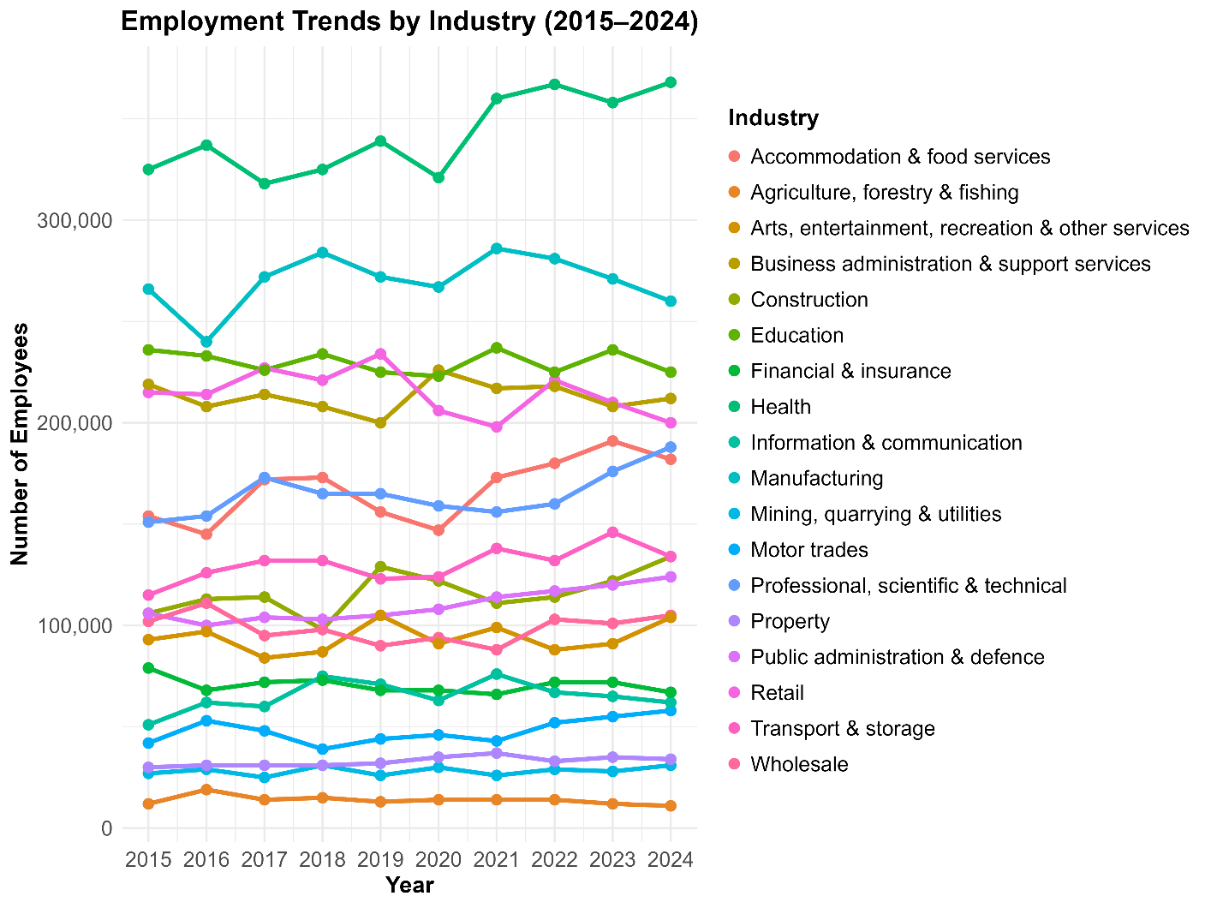
Note. The line plot illustrates the total number of employees (y-axis) across years (x-axis) for each industry included in the dataset. Each coloured line represents a distinct industry, showing broad differences in employment scale and variation over time.

Figure 2
Employment trends of the top five industries in Yorkshire and the Humber (2015–2024)
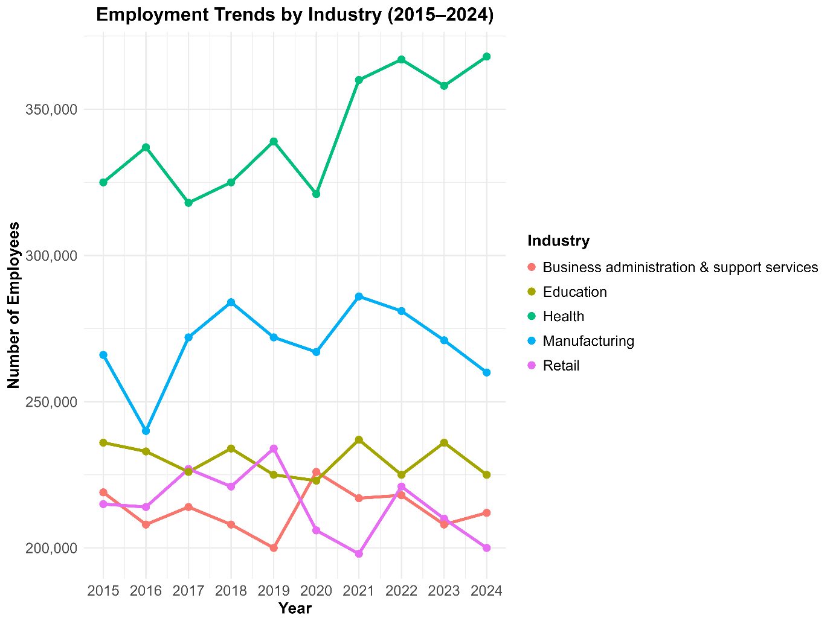
Note. The line plot shows the number of employees (y-axis) across years (x-axis). Health is shown in green, Manufacturing in blue, Business Administration & Support Services in red, Education in yellow, and Retail in pink.

Industries with Consistent Growth (RQ1)
Analysis of employment growth between 2015 and 2024 revealed considerable variation across industries. Motor Trades experienced the fastest proportional growth at 38.1%, followed by Construction (26.4%), Professional, Scientific & Technical services (24.5%), and Information & Communication (21.6%). Moderate growth was observed in Accommodation & Food Services (18.2%) and Health (13.2%). In contrast, several traditionally large industries experienced declines, including Manufacturing (-2.3%), Business Administration & Support Services (-3.2%), Retail, Education, Agriculture, and Financial & Insurance, which declined by up to -15.2%. These patterns are summarised in Figure 3, which presents the percentage employment growth by industry across the period.
Figure 3
Percentage employment growth by industry in Yorkshire and the Humber between 2015 and 2024
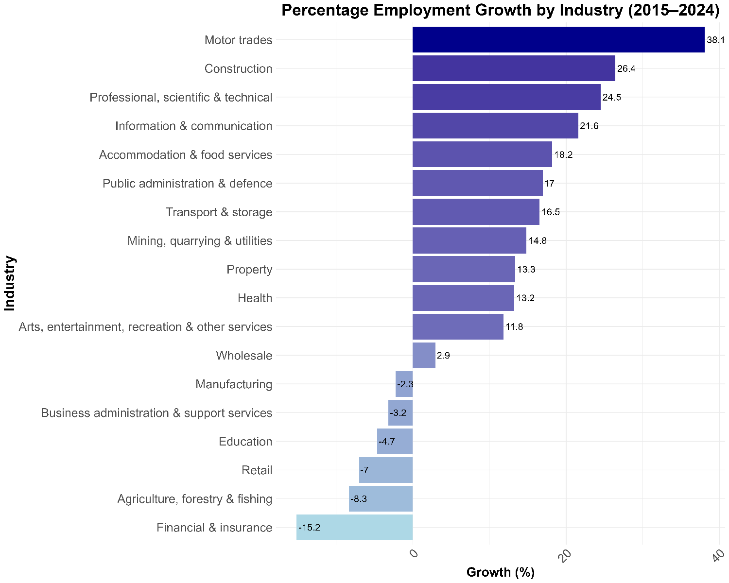
Note. Industries are ordered from lowest to highest growth, with bars coloured along a gradient from light blue (lower growth) to dark blue (higher growth). Values are labelled to indicate exact percentage change over the period.

COVID-19 Employment Impact (RQ2)
Between 2019 and 2021, the effects of the COVID-19 pandemic on employment were uneven across sectors. Property recorded the largest increase at +15.6%, followed by Transport & Storage (+12.2%) and Accommodation & Food Services (+10.9%). Public Administration & Defence (+8.6%) and Business Administration & Support Services (+8.5%) also expanded, while Health (+6.2%), Education (+5.3%), Manufacturing (+5.1%), and several other sectors showed moderate gains. Mining, Quarrying & Utilities remained stable with no significant change.
Conversely, Retail (-15.4%) and Construction (-14.0%) experienced the largest declines, with smaller contractions in Professional, Scientific & Technical (-5.5%), Arts, Entertainment, Recreation & Other Services (-5.7%), and Financial & Insurance (-2.9%). The mixed pattern of growth and decline across sectors is illustrated in Figure 4, highlighting the differing resilience of industries during the pandemic.
Figure 4
Employment change in Yorkshire industries during the COVID-19 pandemic (2019–2021)
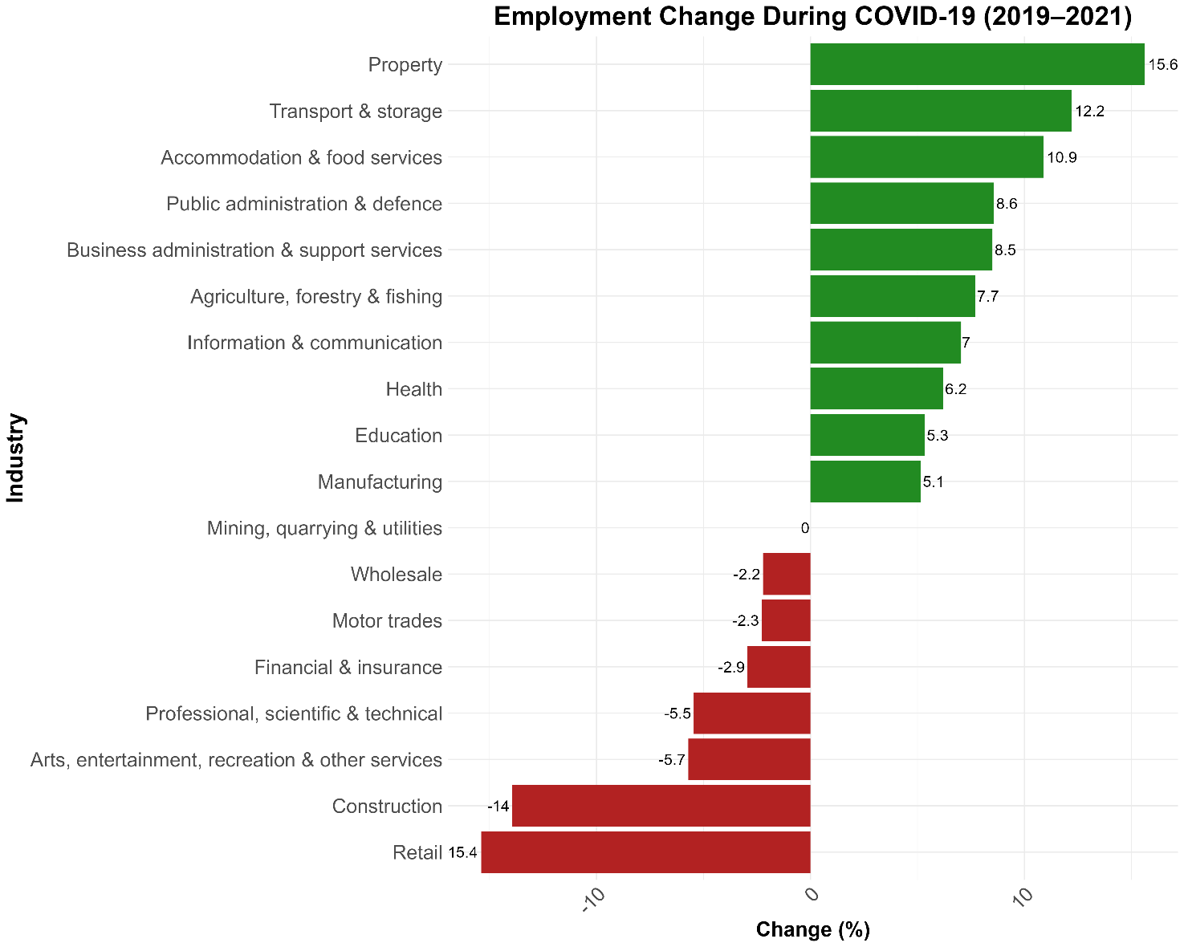
Note. Positive changes are shown in green and negative changes in red, with value labels indicating the percentage change for each industry. Industries are ordered from largest to smallest change.

Predicting Future Employment to 2030 (RQ3)
Linear regression models were fitted to historical employment data from 2015 to 2024 to forecast future employment levels in 2030. Table 1 summarises predicted employment figures by industry, showing baseline values for 2024, forecasted employment in 2030, and projected percentage growth. The largest predicted increases were observed in Information & Communication (+20.6%), Property (+14.5%), Accommodation & Food Services (+13.1%), and Transport & Storage (+12.8%). Moderate growth was predicted for Public Administration & Defence (+9.5%), Manufacturing (+8.9%), and Health (+7.9%), while Motor Trades (+3.8%) and Construction (+3.3%) showed smaller increases. Education (+0.1%) and Business Administration & Support (+0.8%) remained largely stable. Sectors expected to decline included Mining, Quarrying & Utilities (-1.2%), Retail (-1.9%), Arts, Entertainment & Recreation (-3.7%), Financial & Insurance (-4.4%), Wholesale (-7.8%), and Agriculture, Forestry & Fishing (-9.3%). These forecasts are illustrated in Figure 5, which shows predicted employment growth percentages, Figure 6, which combines historical trends with 2030 predictions, and Figure 7, which displays the projected distribution of employment across industries in 2030.

Table 1
Projected employment by industry in Yorkshire and the Humber (2024-2030)
Rank | Industry | Employees (2024) | Predicted (2030) | Projected Growth (%)
1 | Information & Communication | 62,000 | 74,745 | +20.6
2 | Property | 34,000 | 38,945 | +14.5
3 | Accommodation & Food Services | 182,000 | 205,800 | +13.1
4 | Transport & Storage | 134,000 | 151,200 | +12.8
5 | Public Administration & Defence | 124,000 | 135,745 | +9.5
6 | Manufacturing | 260,000 | 283,200 | +8.9
7 | Health | 368,000 | 396,909 | +7.9
8 | Motor Trades | 58,000 | 60,218 | +3.8
9 | Construction | 134,000 | 138,382 | +3.3
10 | Professional, Scientific & Technical | 188,000 | 189,455 | +0.8
11 | Business Administration & Support | 212,000 | 213,636 | +0.8
12 | Education | 225,000 | 225,164 | +0.1
13 | Mining, Quarrying & Utilities | 31,000 | 30,618 | –1.2
14 | Retail | 200,000 | 196,145 | –1.9
15 | Arts, Entertainment & Recreation | 104,000 | 100,200 | –3.7
16 | Financial & Insurance | 67,000 | 64,073 | –4.4
17 | Wholesale | 105,000 | 96,855 | –7.8
18 | Agriculture, Forestry & Fishing | 11,000 | 9,982 | –9.3

Figure 5
Predicted employment growth by Yorkshire industry between 2024 and 2030
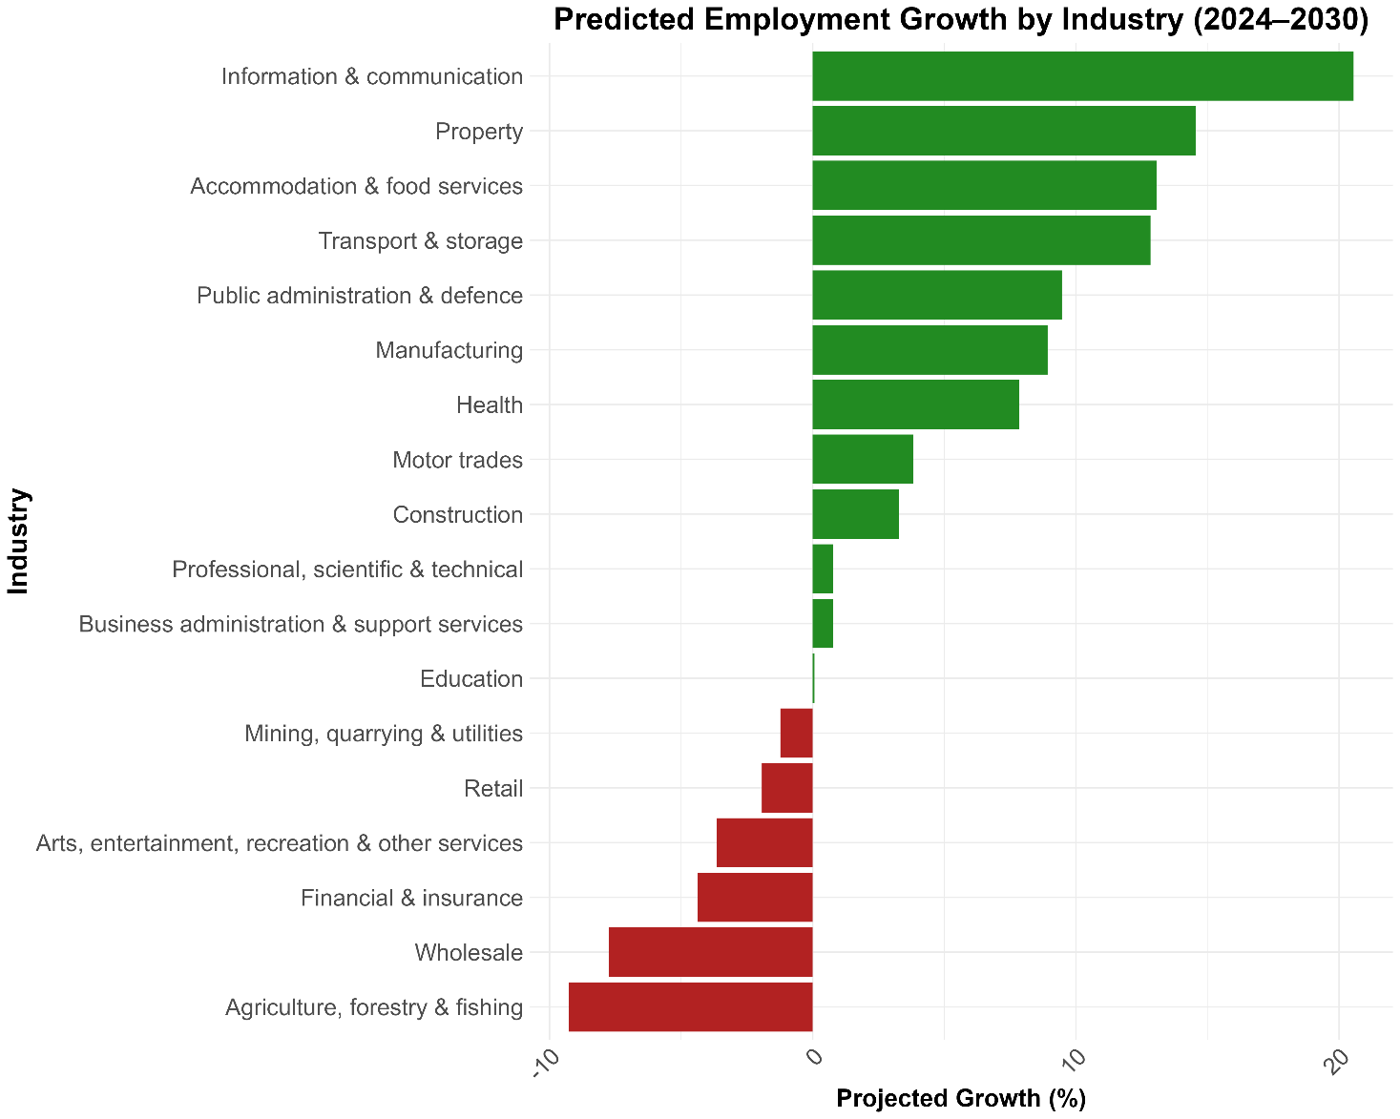
Note. Positive projected growth is shown in green, while negative growth is in red. Industries are ordered by projected growth percentage, with value labels indicating the percentage change.

Figure 6
Historical employment trends (2015–2024) with predicted employment for 2030 across Yorkshire industries
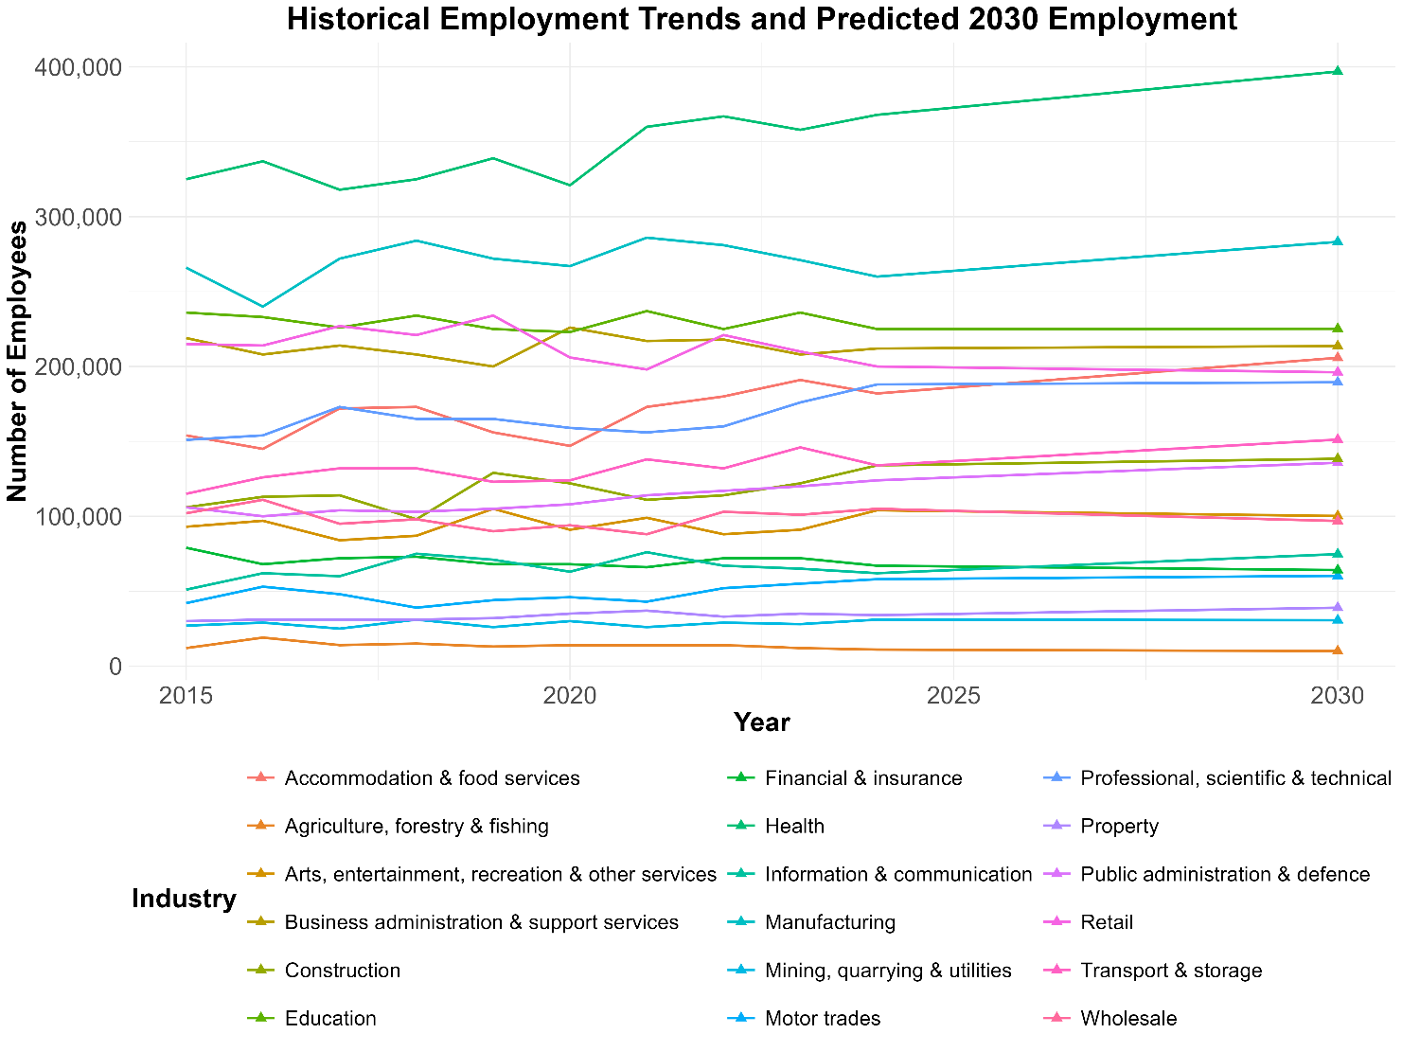
Note. The line plot shows historical data, while the 2030 predictions are highlighted with triangle markers to indicate expected future employment levels.

Figure 7
Predicted distribution of employment across industries in Yorkshire for 2030.
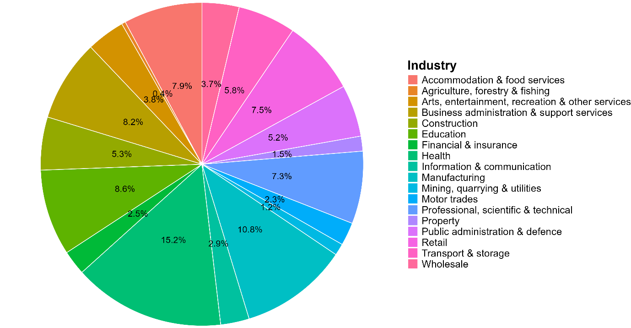
Note. The pie chart shows each industry’s share of total employment, highlighting the relative sizes of sectors based on projected growth trends.

Discussion

Interpreting Employment Trends
The analysis of employment in Yorkshire and the Humber from 2015 to 2024 demonstrates a combination of stability in traditional sectors and gradual diversification towards emerging industries. Health and Manufacturing continue to dominate in absolute employment, reflecting sustained demand for healthcare services and ongoing industrial activity, as illustrated in Figures 1 and 2. In contrast, sectors such as Information & Communication, Professional, Scientific & Technical services, and Accommodation & Food Services exhibit higher proportional growth, highlighting the region’s gradual transition towards knowledge- and service-oriented employment. These findings indicate that while established industries remain critical to regional employment, growth is increasingly driven by technology and services.

Industries with Consistent Growth (RQ1)
Industries showing consistent growth over the period 2015–2024, particularly Motor Trades, Construction, Professional & Technical Services, and Information & Communication, represent emerging strengths within the regional economy. Figure 3 demonstrates that these sectors recorded the highest proportional increases, suggesting that they are key drivers of diversification. Conversely, traditionally large industries such as Retail, Education, and Business Administration & Support Services displayed slower growth or modest decline, reflecting stabilisation rather than contraction. This pattern underscores the ongoing shift in the regional employment landscape, with high-growth sectors complementing the continued presence of established industries.

COVID-19 Employment Impact (RQ2)
The COVID-19 pandemic had an uneven impact on employment across industries, as shown in Figure 4. Sectors such as Property, Transport & Storage, and Accommodation & Food Services demonstrated short-term growth, reflecting adaptability to changes in demand and operational flexibility. In contrast, Construction, Retail, and Arts-related industries experienced notable declines due to restrictions on physical operations and reduced consumer activity. These findings highlight the vulnerability of industries reliant on face-to-face interactions and discretionary spending, while digitally enabled and essential services were able to maintain or even expand employment. The pandemic thus accentuated structural differences in sectoral resilience within the region.

Predicting Future Employment (RQ3)
Projections to 2030, based on linear regression models of historical data, indicate both continuity and change in the regional workforce. Health and Manufacturing are expected to maintain dominance in absolute employment, while sectors such as Information & Communication and Property are forecast to experience substantial proportional growth (Figures 5 and 6). Some traditionally large sectors, including Wholesale, Agriculture, and Financial & Insurance, are predicted to decline modestly. Figure 7 illustrates the projected distribution of employment in 2030, showing the increasing influence of high-growth sectors. These trends suggest that regional policymakers and workforce planners should focus on aligning skills development with growing industries while supporting sectors facing stagnation or decline.

Policy and Strategic Considerations
The findings carry several implications for regional economic planning. Targeted skills development in digital, technical and professional domains can help ensure the workforce meets the demand of expanding sectors. Sustaining capacity in established industries such as Health and Manufacturing is crucial for economic stability, while support for declining sectors can mitigate risks associated with structural changes. Promoting diversification across industries reduces overreliance on a single sector and enhances the resilience and adaptability of the regional economy (Yaman & Tuncel, 2025). The combination of historical trends and 2030 projections provides evidence to guide investment, training and policy priorities within Yorkshire and the Humber.

Limitations and Future Research
This study is constrained by several limitations. Employment data were analysed at the industry level, which may obscure variations at the occupational level. Linear regression projections assume the continuation of historical trends and do not account for potential structural changes, policy interventions or economic shocks (Xiao & Jin, 2021). Additionally, the regional focus does not consider broader national or global influences, such as migration, trade, or technological disruption (Baldwin et al., 2025). Future research could incorporate occupational-level data, scenario-based predictive modelling, and analyses linking regional employment dynamics to wider economic and demographic factors. Such approaches would provide a more nuanced understanding of Yorkshire’s labour market and strengthen the evidence base for strategic planning.

Conclusion

Summary of Key Findings
This study examined employment trends across Yorkshire and the Humber from 2015 to 2024, the impact of the COVID-19 pandemic, and projections to 2030. Traditional sectors such as Health and Manufacturing remain central to the region’s employment, showing both historical stability and strong absolute workforce sizes. Emerging sectors, including Information & Communication, Professional & Technical Services, and Accommodation & Food Services, are driving proportional growth, highlighting a gradual shift towards knowledge- and service-based employment. The COVID-19 pandemic affected industries unevenly, with digitally enabled and essential services proving more resilient, while sectors reliant on physical presence experienced notable declines. Projections to 2030 indicate continued growth in high-demand sectors, alongside modest declines in some traditional industries, suggesting the need for strategic workforce planning.

Broader Implications
These findings emphasise the importance of targeted skills development, policy support, and sectoral investment. By aligning workforce capabilities with emerging sectoral demand, regional stakeholders can foster both economic resilience and diversification. Maintaining capacity in established industries ensures stability, while supporting sectors facing stagnation or decline helps mitigate the risks of structural shifts. The analysis underscores the potential for a balanced regional economy in which traditional sectors coexist with high-growth, technology- and service-oriented industries.

Reflection on Limitations and Future Work
While the study provides valuable insights, it is constrained by reliance on industry-level data, assumptions inherent in linear forecasting, and the exclusion of broader national or global economic influences. Future research could address these limitations by incorporating occupational-level data, scenario-based modelling that accounts for policy and technological changes, and analyses linking regional trends with wider economic and demographic factors. Such approaches would strengthen understanding of Yorkshire’s evolving labour market and enhance the evidence base for strategic decision-making.

Lessons Learned
The project demonstrates the power of combining historical data analysis, predictive modelling, and visualisation to understand regional employment dynamics. It highlights the value of interpreting quantitative results within socioeconomic contexts and the importance of clear communication in conveying insights. Overall, the study reinforces the role of data-driven approaches in informing workforce planning, policy development, and sustainable regional growth.

Engagement Reflection

Insights from Industry and Alumni Events
Participation in industry sessions and alumni events provided practical perspectives on the priorities and challenges within data science. Discussions with professionals emphasised the growing demand for regional economic analytics, predictive modelling and evidence-based decision-making in both public and private sectors. Insights gained highlighted the importance of interpreting employment data not just statistically but in the context of local policy, demographic trends, and technological change.
Alumni reflections reinforced the value of communicating data effectively to non-technical stakeholders, such as local councils, business leaders, and workforce planners. The sessions also underscored the necessity of understanding sector-specific drivers of employment growth, such as digitalisation in services, automation in manufacturing, and demographic shifts in healthcare. These interactions helped frame the analysis in a real-world context, ensuring that the project outcomes are relevant and actionable for regional economic planning

Broader Understanding of Data Science Practice
This project, combined with engagement activities, broadened my appreciation of data science as both a technical and strategic discipline. Beyond coding and statistical modelling, data science involves problem framing, stakeholder communication, and ethical handling of data. The experience emphasised the importance of reproducibility, transparency, and clear visualisation when presenting findings to diverse audiences.
Additionally, engagement with professionals illustrated how data-driven insights can influence policy, business strategy and resource allocation. I gained a stronger understanding of the iterative nature of analysis, where exploration, cleaning and modelling are continuously refined based on domain knowledge and stakeholder needs. These lessons reinforce that successful data science projects require a combination of technical proficiency, contextual understanding, and communication skills, which are critical for both academic and professional practice.

References
Aparicio, G., Iturralde, T., & Rodríguez, A. V. (2021). Developments in the knowledge-based economy research field: a bibliometric literature review. Management Review Quarterly. https://doi.org/10.1007/s11301-021-00241-w

Baldwin, R., Haaland, J. I., & Venables, A. J. (2025). Technical change, jobs, and wages in the global economy. Journal of International Economics, 155, 104065. https://doi.org/10.1016/j.jinteco.2025.104065

Barzotto, M., Corradini, C., & Labory, S. (2025). Work, places and industries in the post-COVID-19 economy. Regional Studies, 59(1). https://doi.org/10.1080/00343404.2025.2524578

Beatty, C., & Fothergill, S. (2021). BEYOND THE PANDEMIC: Older industrial Britain in the wake of the crisis. https://shura.shu.ac.uk/29414/1/beyond-the-pandemic.pdf

Casson, R. J., & Farmer, L. D. (2014). Understanding and checking the assumptions of linear regression: a primer for medical researchers. Clinical & Experimental Ophthalmology, 42(6), 590–596. https://doi.org/10.1111/ceo.12358

Harari, D., & Ward, M. (2022). Regional and National Economic Indicators. Commonslibrary.parliament.uk. https://commonslibrary.parliament.uk/research-briefings/sn06924/

Kaye, A. (2020). Economic impact of covid-19 pandemic on health care facilities and systems: International perspectives. Best Practice & Research Clinical Anaesthesiology, 35(3). https://doi.org/10.1016/j.bpa.2020.11.009

Martin, R., & Sunley, P. (2015). On the notion of regional economic resilience: conceptualization and explanation. Journal of Economic Geography, 15(1), 1–42. https://doi.org/10.1093/jeg/lbu015

Office for National Statistics. (2020). Early insights of how the coronavirus (COVID-19) pandemic impacted the labour market - Office for National Statistics. Www.ons.gov.uk. https://www.ons.gov.uk/employmentandlabourmarket/peopleinwork/employmentandemployeetypes/articles/earlyinsightsofhowthecoronaviruscovid19pandemicimpactedthelabourmarket/july2020

ONS. (2023). Office for National Statistics. Ons.gov.uk. https://www.ons.gov.uk/

PWC. (2023, June 20). One in four workers looking for new jobs as cost of living concerns bite: PwC Global Workforce Hopes & Fears Survey. PwC. https://www.pwc.com/gx/en/news-room/press-releases/2023/pwc-global-workforce-hopes-and-fears-survey-2023.html

Xiao, Y., & Jin, Z. (2021). The Forecast Research of Linear Regression Forecast Model in National Economy. OALib, 08(08), 1–17. https://doi.org/10.4236/oalib.1107797

Yaman, S., & Tuncel, M. B. (2025). The benefits of sectoral diversification for investors with different risk perceptions. Borsa Istanbul Review. https://doi.org/10.1016/j.bir.2025.02.008

Appendix

Appendix A – R Code
#========================================================#
# Yorkshire Industry Employment Analysis (2015–2024)#
#========================================================#

#-------------------------#
# Libraries #
#-------------------------#
library(readxl)
library(tidyverse)
library(stringr)
library(ggpubr)
library(ggrepel)
library(scales)

#-------------------------#
# Loading Data #
#-------------------------#
bres <- read_excel("bres_yorkshire_industry.xlsx") %>%
select(-contains("Flags")) %>% # Removes unnecessary columns
mutate(Industry = str_replace(Industry, "^\\d+\\s*:\\s*", "") %>%
str_replace("\\s*\\([^)]*\\)$", "")) # Clean names

bres_long <- bres %>%
pivot_longer(cols = `2015`:`2024`, names_to = "Year", values_to = "Employees") %>%
mutate(Year = as.numeric(Year))

#-------------------------#
# Exploratory Analysis #
#-------------------------#
summary(bres_long$Employees)
length(unique(bres_long$Industry))

regional_trend <- bres_long %>%
group_by(Year) %>%
summarise(TotalEmployment = sum(Employees, na.rm = TRUE))

#-------------------------#
# Employment Trends #
#-------------------------#
employment_trends_all_industries <- ggplot(bres_long, aes(Year, Employees, colour = Industry)) +
geom_line(size = 2) +
geom_point(size = 4) +
scale_y_continuous(labels = comma) +
scale_x_continuous(breaks = 2015:2024) +
labs(title = "Employment Trends by Industry (2015–2024)",
x = "Year", y = "Number of Employees", colour = "Industry") +
theme_minimal(base_size = 20) +
theme(plot.title = element_text(face = "bold", size = 26, hjust = 0.5),
axis.title = element_text(face = "bold", size = 22),
axis.text = element_text(size = 20),
legend.title = element_text(size = 22, face = "bold"),
legend.text = element_text(size = 20),
legend.key.height = unit(1.2, "cm"),
legend.key.width = unit(0.25, "cm"))

ggsave("employment_trends_all_industries.png", plot = employment_trends_all_industries, width = 16, height = 12, dpi = 300)

#-------------------------#
# Top 5 Industries #
#-------------------------#
top_industries <- bres_long %>%
group_by(Industry) %>%
summarise(TotalEmployees = sum(Employees, na.rm = TRUE)) %>%
arrange(desc(TotalEmployees)) %>%
slice_head(n = 5)

bres_top <- bres_long %>% filter(Industry %in% top_industries$Industry)

ggplot(bres_top, aes(Year, Employees, colour = Industry)) +
geom_line(size = 2) +
geom_point(size = 4) +
scale_y_continuous(labels = comma) +
scale_x_continuous(breaks = 2015:2024) +
labs(title = "Employment Trends for the Top 5 Industries (2015–2024)",
x = "Year", y = "Number of Employees", colour = "Industry") +
theme_minimal(base_size = 20) +
theme(plot.title = element_text(face = "bold", size = 26, hjust = 0.5),
axis.title = element_text(face = "bold", size = 22),
axis.text = element_text(size = 20),
legend.title = element_text(size = 22, face = "bold"),
legend.text = element_text(size = 20),
legend.key.height = unit(1.2, "cm"),
legend.key.width = unit(0.25, "cm"))

ggsave("employment_trends_top5_industries.png", width = 16, height = 12, dpi = 300)

#========================================================#
# RQ1 #
# Industries with the most consistent growth #
#========================================================#
industry_growth <- bres_long %>%
group_by(Industry) %>%
summarise(GrowthPercent = ((last(Employees) - first(Employees)) / first(Employees)) * 100) %>%
arrange(desc(GrowthPercent))

ggplot(industry_growth, aes(reorder(Industry, GrowthPercent), GrowthPercent, fill = GrowthPercent)) +
geom_col(show.legend = FALSE) +
geom_text(aes(label = round(GrowthPercent, 1)), hjust = -0.1, size = 5) +
coord_flip() +
scale_fill_gradient(low = "lightblue", high = "darkblue") +
labs(title = "Percentage Employment Growth by Industry (2015–2024)",
x = "Industry", y = "Growth (%)") +
theme_minimal() +
theme(axis.text.x = element_text(angle = 45, hjust = 1, size = 18),
axis.text.y = element_text(size = 18),
axis.title.x = element_text(size = 19, face = "bold"),
axis.title.y = element_text(size = 21, face = "bold"),
plot.title = element_text(face = "bold", hjust = 0.5, size = 24))

ggsave("percentage_growth_by_industry.png", width = 15, height = 12, dpi = 300)

#========================================================#
# RQ2 #
# COVID-19 impact on employment (2019–2021) #
#========================================================#
covid_change <- bres_long %>%
filter(Year %in% c(2019, 2021)) %>%
group_by(Industry) %>%
summarise(ChangeDuringCovid = ((last(Employees) - first(Employees)) / first(Employees)) * 100) %>%
arrange(desc(ChangeDuringCovid))

ggplot(covid_change, aes(reorder(Industry, ChangeDuringCovid), ChangeDuringCovid, fill = ChangeDuringCovid > 0)) +
geom_col(show.legend = FALSE) +
geom_text(aes(label = round(ChangeDuringCovid, 1)),
hjust = ifelse(covid_change$ChangeDuringCovid > 0, -0.1, 1.1), size = 5) +
scale_fill_manual(values = c("TRUE" = "forestgreen", "FALSE" = "firebrick")) +
coord_flip() +
labs(title = "Employment Change During COVID-19 (2019–2021)",
x = "Industry", y = "Change (%)") +
theme_minimal() +
theme(axis.text.x = element_text(angle = 45, hjust = 1, size = 18),
axis.text.y = element_text(size = 18),
axis.title.x = element_text(size = 19, face = "bold"),
axis.title.y = element_text(size = 21, face = "bold"),
plot.title = element_text(face = "bold", hjust = 0.5, size = 24))

ggsave("covid_employment_change.png", width = 15, height = 12, dpi = 300)

#========================================================#
# RQ3 #
# Predicting industry growth/decline by 2030 #
#========================================================#
fit_predict_industry <- function(df, year_pred = 2030) {
model <- lm(Employees ~ Year, data = df)
predicted <- predict(model, newdata = data.frame(Year = year_pred))
tibble(
Industry = unique(df$Industry),
Employees_2024 = df %>% filter(Year == 2024) %>% pull(Employees),
Predicted_2030 = round(predicted),
Projected_Growth_Percent = ((predicted - Employees_2024) / Employees_2024) * 100
)
}

predictions_2030 <- bres_long %>%
group_by(Industry) %>%
group_modify(~fit_predict_industry(.x)) %>%
ungroup() %>%
arrange(desc(Projected_Growth_Percent))

# Bar chart of projected growth
ggplot(predictions_2030, aes(reorder(Industry, Projected_Growth_Percent), Projected_Growth_Percent, fill = Projected_Growth_Percent > 0)) +
geom_col(show.legend = FALSE) +
scale_fill_manual(values = c("TRUE" = "forestgreen", "FALSE" = "firebrick")) +
coord_flip() +
labs(title = "Predicted Employment Growth by Industry (2024–2030)",
x = "Industry", y = "Projected Growth (%)") +
theme_minimal() +
theme(axis.text.x = element_text(angle = 45, hjust = 1, size = 18),
axis.text.y = element_text(size = 18),
axis.title.x = element_text(size = 19, face = "bold"),
axis.title.y = element_text(size = 21, face = "bold"),
plot.title = element_text(face = "bold", hjust = 0.5, size = 24))

ggsave("predicted_employment_change.png", width = 15, height = 12, dpi = 300)

# Historical and 2030 line plot
bres_long_2030 <- bres_long %>%
bind_rows(predictions_2030 %>% transmute(Industry, Year = 2030, Employees = Predicted_2030))

ggplot(bres_long_2030, aes(Year, Employees, colour = Industry)) +
geom_line(size = 1.2) +
geom_point(data = bres_long_2030 %>% filter(Year == 2030), size = 3, shape = 17) +
scale_y_continuous(labels = comma) +
labs(title = "Historical Employment Trends and 2030 Predictions",
x = "Year", y = "Number of Employees") +
theme_minimal() +
theme(plot.title = element_text(face = "bold", size = 26, hjust = 0.5),
axis.title = element_text(face = "bold", size = 22),
axis.text = element_text(size = 20),
legend.title = element_text(size = 22, face = "bold"),
legend.text = element_text(size = 17),
legend.key.height = unit(1.2, "cm"),
legend.key.width = unit(1, "cm"),
legend.position = "bottom") +
guides(colour = guide_legend(ncol = 3))

ggsave("2030_predictions_line_graph.png", width = 16, height = 12, dpi = 300)

# Pie chart of predicted 2030 employment
predictions_2030_pie <- predictions_2030 %>%
mutate(Share = Predicted_2030 / sum(Predicted_2030) * 100,
Label = paste0(round(Share, 1), "%"))

ggplot(predictions_2030_pie, aes(x = 1, y = Share, fill = Industry)) +
geom_col(color = "white") +
coord_polar(theta = "y") +
geom_text(aes(label = Label), position = position_stack(vjust = 0.5), size = 5, colour = "black") +
labs(title = "Predicted Employment Distribution by Industry (2030)", fill = "Industry") +
theme_void() +
theme(plot.title = element_text(face = "bold", size = 22, hjust = 0.5),
legend.title = element_text(face = "bold", size = 20),
legend.text = element_text(size = 16),
legend.position = "right")

ggsave("predicted_2030_employment_piechart.png", width = 14, height = 12, dpi = 300)

Appendix B – GitHub Profile and Project Screenshots

